**Technical Documentation – Compile_FAR_Artifacts_PMP**

1. Workflow – Compiles INPLACE Forms and Reports Artifacts in the BATCH and ONLINE Environments. It can compile selected fmb and rdfs or the entire folder.

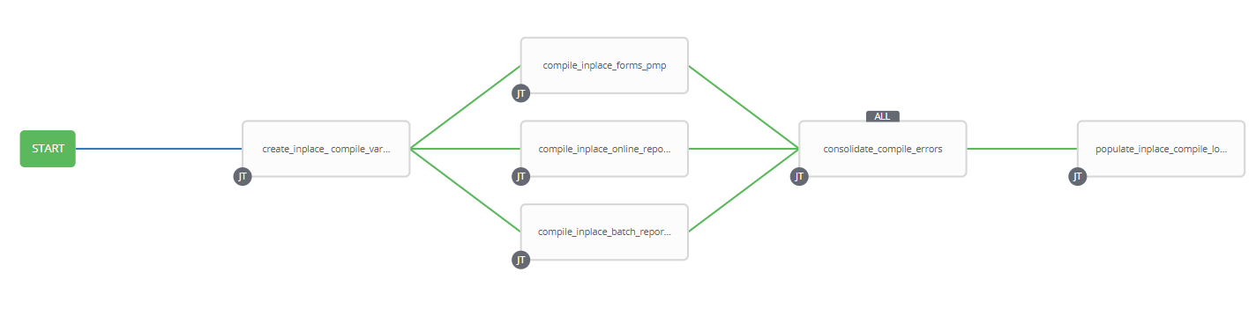

1. Workflow Extra Vars

The Password Manager Pro URL is defined at the workflow level.

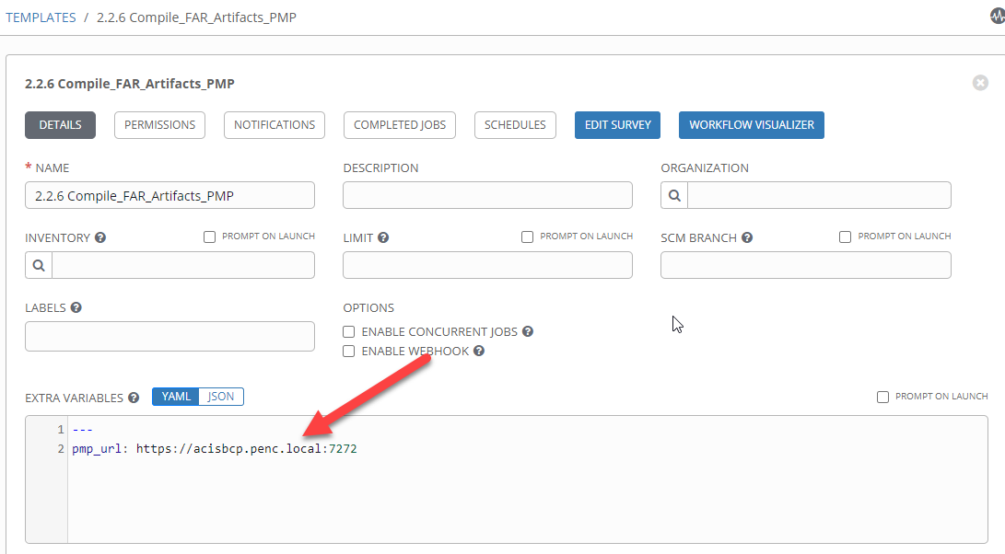

1. Survey – User Supplied Variables

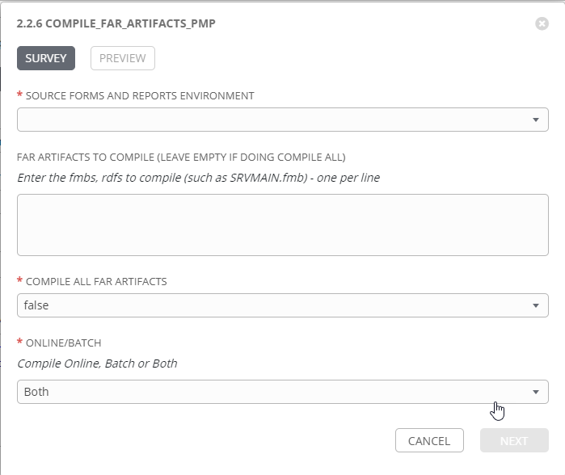

|  |  |  |  |
| --- | --- | --- | --- |
| **Survey Extra Variables** | **Prompt** | **Type** | **Description and Usage** |
| ENV | Compile Environment | Multiple Choice Single Pick | The Environment to Compile and Deploy the FAR Artifact into: DEVL, DEV3, RDEV, TST1, TST2, TST3. Only a single environment can be compiled to per workflow execution |
| FARArtifacts | Online/Batch Forms and Reports Artifacts to compile | Text Area 20,000 characters | Artifact Names (fmbs and rdfs only), a single artifact per line. This should be left empty if CompileAll is set to true |
| CompileAll | Compile All Artifacts | Multiple Choice Single Pick | True or false – default of false will only compile forms and reports that are present in the FARArtifacts Variable. |
| OnlineBatch | Online/Batch  Compile Online, Batch or Both | Multiple Choice Single Pick | Both, Batch or Online – Pick which type of environment to compile in |

1. Jobs Used by the workflow - http://owl.penc.local:18080/svn/deploy_automation/trunk/Ansible_PlayBooks/FAR

| **Job Template** | **Ansible Playbook** | **Credentials / host** | **Project** | **Description and Usage** | |
| --- | --- | --- | --- | --- | --- |
| create_inplace_compile_vars | create_inplace_compile_vars.yml | None – runs on localhost as awx linux user | FAR Deployments | Batch_Compile_Directory: 'D:\Reports\defs\DEVL’  Compile_Directory: /export_home/codemove/compile/ipas12c/DEVL  InplaceCompileLogDirectory: /codemove_common/dp_automation/recompiles/DEVL/20210811_0932  Oracle_DB: DEVL  Runtime_Directory: /export_home/codemove/compile/ipas12c/devl  Schema: IPASUSER  WEB_Compile_Directory: /export_home/codemove/compile/ipas12c/webd  batch_far_server: cronrepdev1  date_time: '20210811_0932'  far_server: daulis1bcp  rwconverter: 'D:\opt\oracle\domains\WLS_JCSDEV\reports\bin\rwconverter.bat'  stage_server: diagoras1bcp  tower_hostname: pdeploy1bcp.penc.local | |
| compile_inplace_forms_pmp | compile_inplace_forms_pmp.yml | Codemove for {{far_server}} typically daulis1bcp  PMP_ANSIBLE_AUTH_TOKEN for the Ansible Password Manager Pro API | FAR Deployments | When {{FAR_Artifacts}} is populated with an Online Form and {{CompileAll}} is set to ‘false’, compiles it if {{OnlineBatch}} is ‘Both’ or ‘Online’.  If {{CompileAll}} is set to ‘true’ and {{OnlineBatch}} is ‘Both’ or ‘Online, compiles All fmbs, plls and mmbs  Obtains the {{Schema}} Resource and Accound IDs from password managerpro using the {{ans_auth_token}} by passing in {{Schema}} and {{Oracle_DB}}_{{Schema}} to the getResourceAccountDetails API.  Obtains the password from Password Manager Pro by passing the RESOURCEID and ACCOUNTID to the getResourceAccountDetails API.  Checks the password against the {{Oracle_DB}} using sqlplus.  When CompileAll is set to true compile_single_form_pll.yml is called to compile all plls. When a new form pll is migrated it is assumed that CompileAll is set to true, by default it is set to false and NO plls are compiled.  If any of the pll compiles result in an error {{Form_PLL_Errors}} is updated.  {{Form_PLL_Feedback}} is updated for each plx created.  When CompileAll is set to true compile_single_menu.yml is executed against all mmb files in the {{Compile_Directory}}. If CompileAll is set to false compile_single_menu.yml is executed against all mmb files in the {{StageDir}}/artifacts/Online directory. The resulting mmx files are copied to the {{Runtime_Directory}}.  If any of the mmb compiles result in an error {{Form_Menus_Errors}} is updated.  {{Form_Menu_Feedback}} is updated for each mmx created.  When CompileAll is set to true compile_inplace_forms_pmp.yml compiles the REFERENC.fmb.  If REFERENC.fmb fails to compile {{Referenc_Forms_Errors}} is updated.  If REFERENC.fmb compiles successfully, the resulting fmx is removed and the compiled REFERENC.fmb is copied to the {{Runtime_Directory}}. REFERENCE.fmb is ONLY compiled when CompileAll is set to true as ALL Forms will need to be compiled if a new REFERENC.fmb is deployed.  When CompileAll is set to true compile_single_form_new.yml is executed against all fmb files in the {{Compile_Directory}}. If CompileAll is set to false compile_single_form.yml is executed against all fmb files in the {{StageDir}}/artifacts/Online directory. The resulting fmx files are copied to the {{Runtime_Directory}}.  If any of the fmb compiles result in an error {{Form_Errors}} is updated.  {{Form_Feedback}} is updated for each fmx created | |
| compile_inplace_reports_pmp | ompile_inplace_reports_pmp.yml | Codemove for {{far_server}} typically daulis1bcp  PMP_ANSIBLE_AUTH_TOKEN for the Ansible Password Manager Pro API | FAR Deployments | When {{FAR_Artifacts}} is populated with an Online Report and {{CompileAll}} is set to ‘false’, compiles it if {{OnlineBatch}} is ‘Both’ or ‘Online’.  If {{CompileAll}} is set to ‘true’ and {{OnlineBatch}} is ‘Both’ or ‘Online, compiles All rdfs  compiles pll and rdf files.  Obtains the {{Schema}} Resource and Accound IDs from password managerpro using the {{ans_auth_token}} by passing in {{Schema}} and {{Oracle_DB}}_{{Schema}} to the getResourceAccountDetails API.  Obtains the password from Password Manager Pro by passing the RESOURCEID and ACCOUNTID to the getResourceAccountDetails API.  Checks the password against the {{Oracle_DB}} using sqlplus.  When CompileAll is true the compile_single_report_pll.yml is executed which will compile NOTC.pll, RPT_ROLE.pll and IPASRPT.pll. It is assumed CompileAll will be set to true if ANY new pll is deployed. By default it is set to ‘false’.  If any of the pll compiles produces an error {{Report_PLL_Errors}} is populated.  Each plx created is copied to {{Runtime_Directory}}.  {{Report_PLL_Feedback}} is populated for each plx created.  When CompileAll is true compile_single_report_new.yml is executed against ALL rdf files in the {{Compile_Directory}}. If CompileAll is false, compile_single_report.yml is executed only against rdf files in the {{StageDir}}/artifacts/Online.  If any of the rdf compiles produces an error {{Report_Errors}} is populated.  Each rep created is copied to {{Runtime_Directory}}.  {{Report_Feedback}} is populated for each rep created. | |
| compile_inplace batch_reports | compile_inplace_batch_reports.yml  Calls  compile_single_batch_form_pll.yml  and  compile_single_batch_report_new.yml | Penc\ora_cronreptest for {{batch_far_server}} – cronreptest1  PMP_ANSIBLE_AUTH_TOKEN for the Ansible Password Manager Pro API | FAR Deployments | compile_batch_reports, compiles FORM pll and rdf files.  Obtains the IPASUSER Resource and Accound IDs from password managerpro using the {{ans_auth_token}} by passing in IPASUSER and {{ENV}}_IPASUSER to the getResourceAccountDetails API.  Obtains the password from Password Manager Pro by passing the RESOURCEID and ACCOUNTID to the getResourceAccountDetails API.  Checks the password against the {{ENV}} using sqlplus.  When CompileAll is true the compile_single_batch_form_pll.yml is executed which will compile WEBUTIL.pll, D2KWUTIL.pll, CONST.pll, SYSLIB.pll, SYSMSG.pll, PFXCONST.pll, AUDIT.pll, POS.pll, NOTC.pll, RPT_ROLE.pll, IPSRPT.pll. It is assumed CompileAll will be set to true if ANY new pll is deployed. By default it is set to ‘false’.  If any of the pll compiles produces an error {{Batch_Form_PLL_Errors}} is populated.  {{Batch_Form_PLL_Deployment_Feedback}} is populated for each plx created.  When CompileAll is true compile_single_batch_report_new.yml is executed against ALL rdf files in the {{Batch_Compile_Directory}}. If CompileAll is false, compile_single_report.yml is executed only against rdf files in the {{StageDir}}/artifacts/Batch.  If any of the rdf compiles produces an error {{Batch_Report_Errors}} is populated.  {{Batch_Report_Deployment_Feedback}} is populated for each rep created. |
| consolidate_compile_errors | consolidate_compile_errors.yml | None – runs on localhost as awx linux user | FAR Deployments | Consolidates all ERRORS generated – Note that this jobs is used by all Forms and Reports workflows (Online, Batch, web, etc.). | |
| populate_inplace_deployment_logs | populated_inplace_deployment_logs.yml | Codemove for {{stage_server}} – diagoras1bcp | FAR Deployments | Populates the deployment log {{DeploymentLogDir}}/{{ENV}}_Inplace_Compile_Log.html with the pll, mmb, fmb and rdf feedback generated during the compiles.  Populates the error logs {{DeploymentLogDir}}/{{ENV}}_Online_Compile_Errors.html with any ERRORS generated during the compiles.  {{DeploymentLogDir}}/{{ENV}}_Batch_Compile_Errors.html with any ERRORS generated during the compiles.  If Compile errors exist emails the Logs to:  - {{tower_user_email}} | |